**VELAMMAL BODHI CAMPUS**

**(A CBSE – IIT/NEET Integrated Sr. Sec. School)**

**GRAND TEST – 1 (2023-24)**

**Grade:** X – Batch I **Sub:** Social Science

**Date:** 20.11.2023 **Marks:** 80

**___________________________________________________________________________**

**General Instruction:**

*(i) This question paper has six sections: Section A, Section B, Section C, Section D, Section E, and Section F. There are 37 questions in the paper. All Questions are compulsory.*

*(ii) Section A contains 20 questions of one mark each (Q.1 to Q.20),*

*(iii) Section B contains 4 questions of two marks each (Q.21 to Q.24),*

*(iv) Section C contains 5 questions of three marks each (Q.25 to Q.29),*

*(v) Section D contains 4 questions of five marks each (Q.30 to Q.33),*

*(vi) Section E contains three case based (Subjective) four marks (Q.34 to Q.36),*

*(vii) Section F Question no.37 is map based, carrying 5 marks with two parts, 37.a from History (2 marks) and 37 b from Geography (3 marks),*

*(viii) There is no overall choice in the question paper. However, an internal choice has been provided in few questions. Only one of the choices in each questions have to be attempted. In addition to this separate instructions are given with each section and question where necessary.*

**Section – A (20x1=20)**

1. Modern democracies maintain check and balance system. Identify the correct option

based on the horizontal power sharing arrangement.

(a) Central government, state government, local bodies

(b) Legislature, executive, judiciary

(c) Among different social groups

(d) Among different pressure groups

2. Which of the following subjects fall under the concurrent list?

(a) Defence (b) Agriculture (c) Marriage (d) Currency

3. If all the decisions of a political party is taken by a single -family and all other

members are neglected then what challenge is being faced by that party.

(a) Challenge of alliance formation (b) Challenge of dynastic succession

(c) Challenge of partial elections (c) Challenge of power

4. What is meant by transparency?

5. Caste hierarchy means-

(a) Shift from one occupation to another

(b) Religious equality

(c) Communal harmony and peace on the base of caste

(d) A ladder like formation in which all the caste groups are placed from the highest to the lowest castes

6. When was Germany unified?

(a) 20th March 1870 (b) 17th April 1872

(c) 18thJanuary 1871 (d) 13th March 1873

7. Identify the appropriate reason for the formation of the Swaraj party from the options given below:

(a) Wanted members of Congress to return to Council Politics

(b) Wanted members of Congress to ask Dominion state for India

(c) Wanted members of Congress to ask for Poorna Swaraj

(d) Wanted members of Congress to ask to oppose Simon Commission

8. Who was the first governor of the Massachusetts Bay Colony in New England?

(a) John Winthorp (b) Marco Polo

(c) M.W.Ridley (d) Michael Fitzgerald

9. **Assertion (A):** By the 17th century, the use of print diversified in China because of a

blooming urban culture.

**Reason (R):** The imperial state in China was the major producers of printed material

(a) Both A and R are true but R is the correct explanation of A

(b) Both A and R are true but R is not the correct explanation of A

(c) A is true ,but R is false

(d) A is false ,but R is true

10. Find the incorrect option.

(a) Martin Luther wrote Ninety Five Thesis

(b) The first printed Tamil Book printed in Madras

(c) In 1870, Hindi printing began seriously

(d) Fairy tales printed by the Grimm Brothers

11. Bhakra Nangal River Valley Project is built on which river?

(a) Ganga (b) Ravi-Chenab (c) Son (d) Sutlej-Beas

12. A type of millet rich in iron, calcium, other micro nutrients and roughage is _______.

(a) Wheat (b) Rice (c) Ragi (d) Coffee

13. In which kind of rocks are the minerals deposited and accumulated in the strata’s?

(a) Igneous rocks (b) Metamorphic rocks

(c) Sedimentary rocks (d) None of these

14. The book ‘Small is Beautiful’ written by ______________,

(a) Schumacher (b) Agatha Christie (c) Ruskin Bond (d) Abhijit Sen

15. **Assertion (A):** Kerala has low Infant Mortality Rate.

**Reason (R):** Kerala has adequate provision of basic health and education facilities.

(a) Both A and R are true but R is the correct explanation of A

(b) Both A and R are true but R is not the correct explanation of A

(c) A is true ,but R is false

(d) A is false ,but R is true

16. Which one of the following was not a traditional form of money?

(a) Grains (b) Paper notes (c) Cattle (d) Gold coins

17. **Assertion (A):** Proper discharge and disposal of industrial wastes can reduce land degradation in suburban areas.

**Reason (R):** In the state of Punjab, Haryana, western Uttar Pradesh over-irrigation is responsible for land degradation.

(a) Both A and R are true but R is the correct explanation of A

(b) Both A and R are true but R is not the correct explanation of A

(c) A is true ,but R is false

(d) A is false ,but R is true

18. Which one of the following agencies markets steel for the public sector plants?

(a) HAIL (b) SAIL (c) TATA Steel (d) MNCC

19. Removing barriers or restrictions set by the government is known as:

(a) Privatisation (b) Liberalisation

(c) Globalisation (d) Industrialisation

20. Which of the following profession belongs to the tertiary sector of economy?

(a) Fisherman (b) Farmer (c) Teacher (d) Factory worker

**Section – B (4x2=8)**

21. Analyse any two reasons for slowing down of Non- Cooperation Movement.

22. "No party system is ideal for all countries and in all situations" Analyse the situation

23. Expand PCI and its formula to calculate.

24. What are unclassed forests?

**Section – C (5x3=15)**

25. Why do we feel that democracy is a better form of government than any other form? Explain.

26. In what ways food offer cultural exchange? Explain

27. Water is available in abundance in India even then scarcity of water is experienced in major parts of the country? Explain.

28. Describe the Geographical condition required for the growth of sugarcane.

29. Describe the bad effects of informal sources of credit on borrowers.

**Section – D (4x5=20)**

30. A. Describe any three steps taken by the French revolutionaries to create a sense of

collective identity amongst the French people.

**(OR)**

B. Describe the explosive conditions prevailed in Balkans after 1871 in Europe.

31. A. Explain the key features of federalism which have been incorporated in the Indian

Constitution.

**(OR)**

B. Why has federalism succeeded in India? Which three policies adopted by India have ensured this success?

32. A. “The economic strength of a country is measured by the development of manufacturing industries.” Explain.

**(OR)**

B. Explain the Pro-active approach adopted by the National Thermal Power Corporation (NTPC) for preserving the natural environment and resources.

33. A. How can we create more employment opportunities in urban areas? Explain with examples.

**(OR)**

B. What are the differences in the employment conditions between organised and unorganised sectors of the economy?

**Section – E (3x4=12)**

**34. Read the source given below and answer the following questions.**

New forms of popular literature appeared in print, targeting new audiences. Booksellers employed pedlars who roamed around villages, carrying little books for sale. There were almanacs or ritual calendars, along with ballads and folktales. But other forms of reading matters. largely for entertainment, began to reach ordinary readers as well. In England, penny chapbooks were carried by petty pedlars known as chapmen, and sold for a penny, so that even the poor could buy them.

In France, were the 'Biliotheque Bleue', which were low-priced small books printed on poor quality paper, and bound in cheap blue covers. Then there were the romances, printed on four to six pages, and the more substantial 'histories' printed on four to six pages and the more substantial 'histories' which were stories about the past. Books were of various sizes, serving many different purposes and interests.

34.1. What were chapbooks? (1)

34.2. How Biliotheque Bleue was different from chapbooks? (1)

34.3. What were the new forms of literature introduced in Europe to attract the new readers? (2)

35. Rice is the staple crop used by the majority of people in India. India is the second largest producer of rice in the world after China. It is a Kharif crop which requires high temperature (above 25 degree Celsius) and high humidity with annual rainfall above 100 cm. In the area of less rainfall, it grows with the help of irrigation. Development of dense network of canal irrigation and tube wells has made it possible to grow rice in areas of less rainfall such as Punjab, Haryana, Western Uttar Pradesh and parts of Rajasthan.

35.1. Name the largest and second largest producer of rice in the world? (1)

35.2. Write the climatic conditions required for the growth of rice? (1)

35.3. How the water requirements of rice are fulfilled in areas of less rainfall? (2)

**36. Read the passage below and answer the following questions:**

Secularism is not just an ideology of some parties or persons. This idea constitutes one of the foundations of our country. Communalism should not be seen as a threat to some people in India. It threatens the very idea of India. That is why communalism needs to be combated. A secular Constitution like ours is necessary but not sufficient to combat communalism. Communal prejudices and propaganda need to be countered in everyday life and religion based mobilisation needs to be countered in the arena of politics.

36.1. What is secularism? (1)

36.2. What constitutional provisions declare India to be a secular state? (1)

36.3. Why do we need to combat communalism? (2)

**Section – F (2+3=5)**

37. Two places A and B have been marked on the given outline map of India.

a. Identify them and write their correct names on the lines marked near them: (2)

(a) The place where the Indian National Congress Session was held in 1927.

(b) The place where Gandhiji organized "Satyagraha' in favour of cotton mill workers.

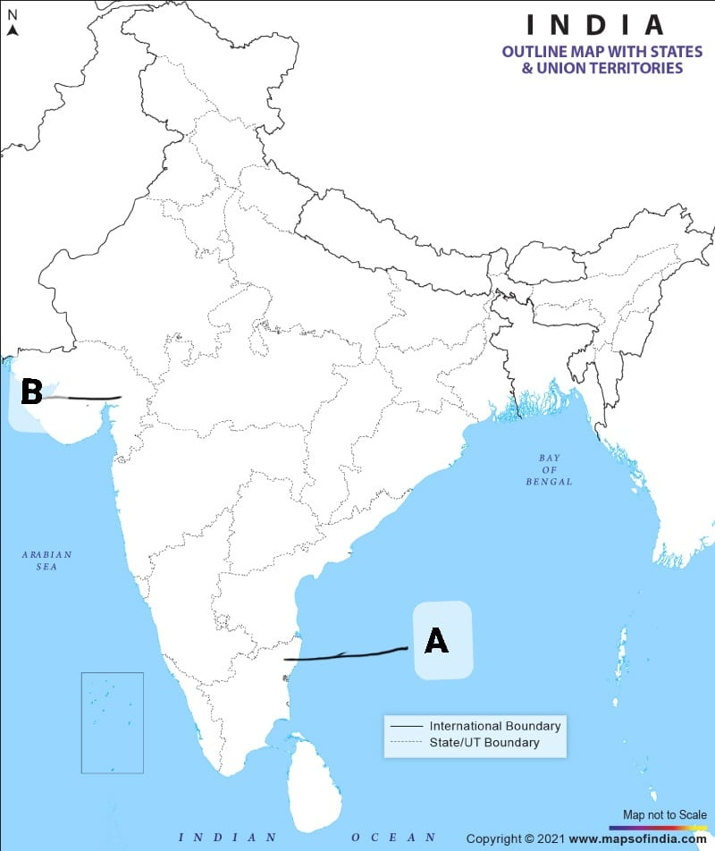

37. b. On the same outline map of India locate and label **ANY THREE** of the following with suitable symbols. (3)

(a) Raja Sansi - International Airport

(b) Bhilai - Iron and Steel Plant

(c) A Software Technology Park in Telangana

(d) A Dam built on the river Mahanadi